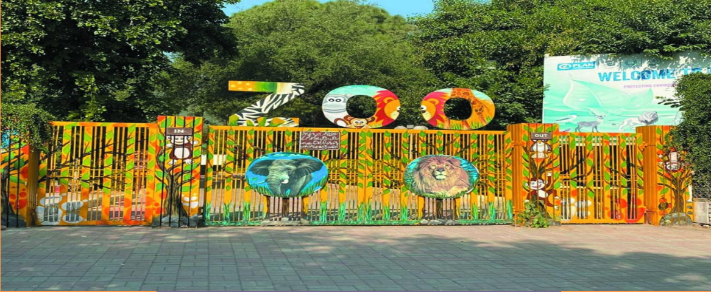

About Isb Marghazar Zoo Park

What is Isb Marghazar Park Zoo? and where is located established? ISB Marghazar Park Zoo, also known as the Marghazar Zoo, is a zoo located in Islamabad, the capital city of Pakistan. It is a popular local attraction that provides a place for residentsand visitors to enjoy wildlife and nature.

Opening & Closed Timings

9:00 AM Open daily to 5:00 PM

he last admission to the ISB Marghazar Park Zoo is typically about 1 hour before closing time. Since the zoo generally closes at 5:00 PM, the last admission is around 4:00 PM.

he family days at the ISB Marghazar Park Zoo typically occur on Sundays or during public holidays, offering special activities and possibly discounted entry fees for families.

The ISB Marghazar Park Zoo typically does not have specific "ladies-only" days, but there have been occasions in various zoos worldwide, including in Islamabad, where special days or hours are designated for women or families. However, for the Marghazar Zoo,there have been no regular, official announcements about specific "ladies-only" hours.

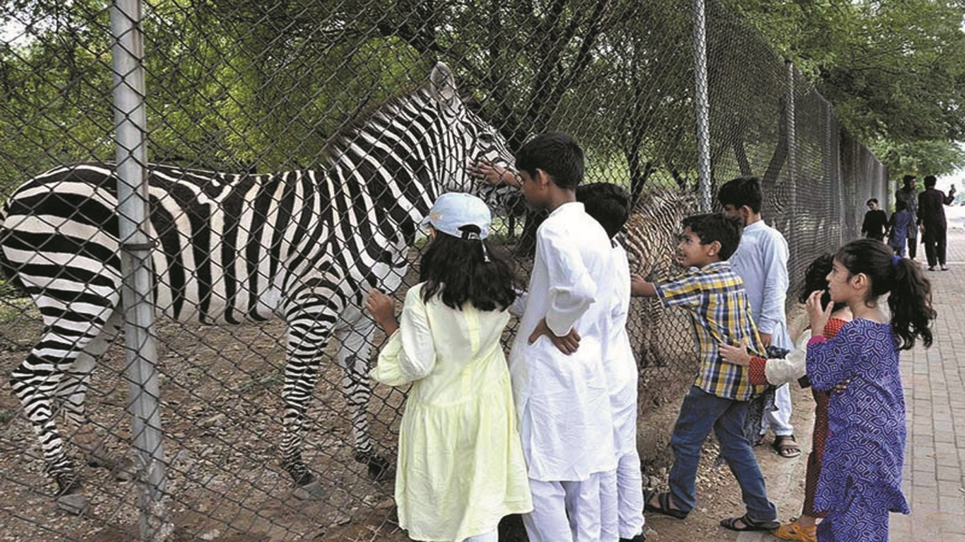

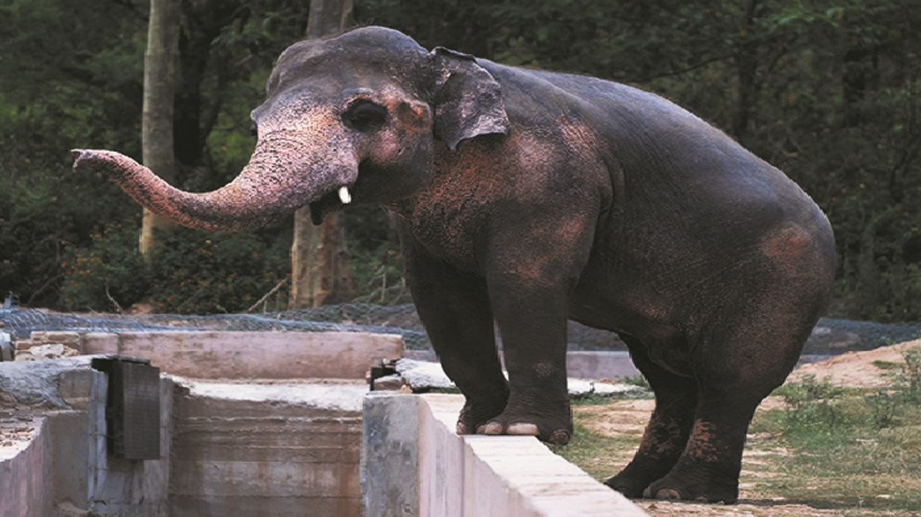

Animals List

The ISB Marghazar Park Zoo in Islamabad, Pakistan, is home to a variety of animals, both native and exotic. Although the zoo is smaller compared to some other major zoos, it houses a selection of animals from different regions.

Lions

Snow leopard

tigers

Fox

Crocodiles

Wild bear

Tortoise

Snakes

Monkeys

Address & Contact

Address: Foothills of the Margalla Hills, a scenic area in Islamabad Pakistan.For questions related to visiting, opening times, directions, accessibility, or other general information, you can visit their [Support Centre](http://iwmb.org.pk).

Email: For specific enquiries you can fill out the contact form available on their (info@iwmb.org.pk).

Phone:For urgent enquiries, you can call their Supporter Contact team at +92 51 9265079.

For the most accurate and up-to-date information, it's recommended to visit the [official Isb Marghazar Zoo website]( http://iwmb.org.pk).